1. **Buisness description**
   1. **Buisness background**

The date of the beginning and end of each climb, the names and addresses of the climbers involved, the name and height of the mountain, the country, and the area where the mountain is located must be recorded in the database. Give descriptive names to the tables and fields in which the information will be entered.

* 1. **Problems. Current situation**

The data is presented in non-standardized form. First it was necessary to reduce the model to the second normal form, then by excluding attributes that indirectly depend on the primary key, obtain the third normal form.

* 1. **The benefits of implementing a database. Project vision**

We will receive complete and ordered data in the form of tables.

A conceptual scheme is currently being sketched out. First you we need to make a conceptual scheme, it will be easier in the future.

1. **Model Description**

**2.1.** A conceptual model is a reflection of the subject area for which the database is being created.

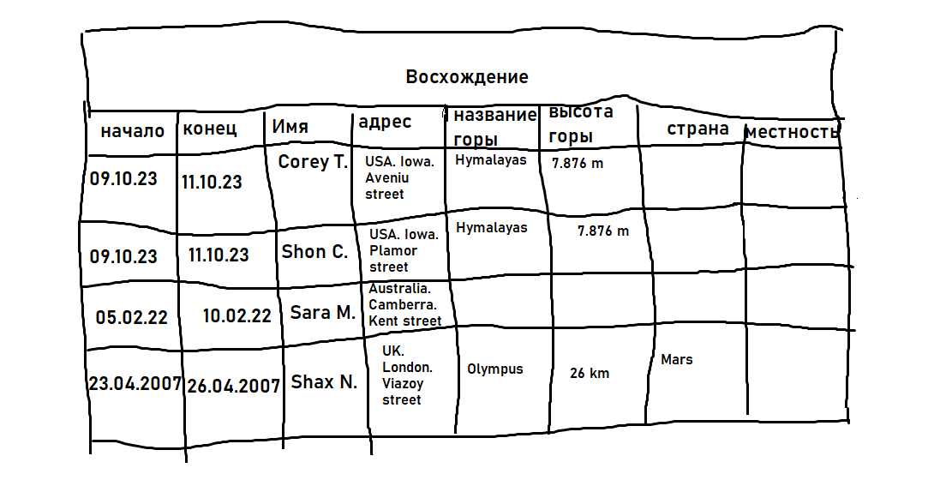

* 1. **Logical Scheme**

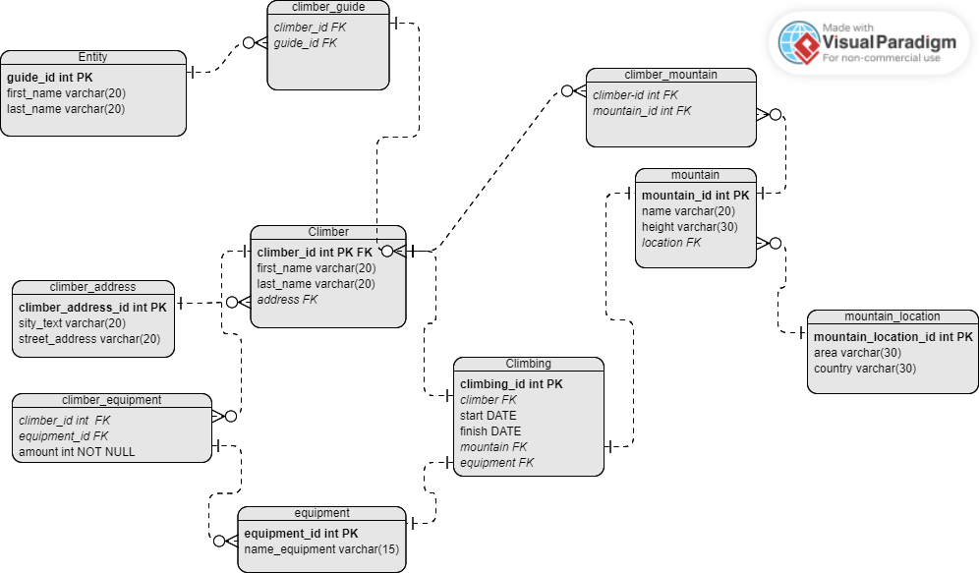

* 1. **Objects**

The business requirements indicate a many-to-many relationship and this is present in the logical diagram: diagram “climber_mountain” connects diagram “climber” and “mountain”. Field “climber_id” referenced by a foreign key on “climber_id” in the table “Climber”. Also field “mountain_id” referenced by a foreign key on “mountain_id” in the Table “mountain” (it’s a many-to-many ralationship).

Also,for example, table “climb_equipment” connects tables “climber” and equipment. It’s an exmple of one-to-many relationship.

**Example with data**

Transferring data to other tables in the process of obtaining higher normal form

